**Project 1:**

**Name:** Noise Detector with Automatic Recording System Using Arduino With The IoT.

**Introduction:**

In this project we use a set of components that work together in order to achieve the goal of quiet and reasonably unobtrusive sound so we use a noise detector that consists of the power the Arduino and connect the Bluetooth with your app When your sound level crosses the threshold value, the Noise Detector device will buzz to notify about it and at the same time the app will start recording the sound and it will go on recording until the noise level comes down below the threshold level.

**Photos for the project:**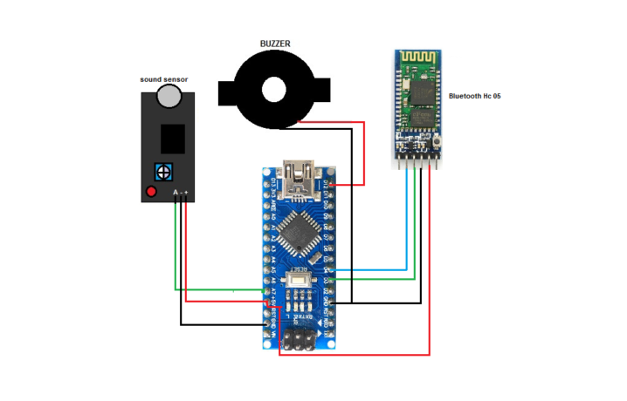

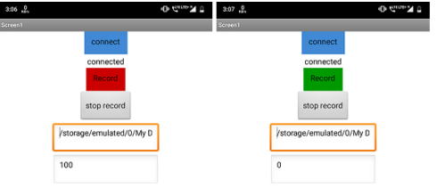

**DisAdvantegs:**Using Bluetooth when our project use network.(Bluetooth:small area connection not enough for library when it may be 2 floors! Even for mobile of librarien, but Network is allowed large area).  
  
The project uses only one level of sound, which is the loud sound only, while our program uses three levels of sound, which is the best so that we can predict and monitor the change of sound levels from low to medium before the loud sound.

**Advanteges :**  
 app will start recording the sound and it will go on recording until the noise level comes down below the threshold level , when our procect doesn’t need sound recorder!.  
  
  
**Link:** <https://www.electronicsforu.com/electronics-projects/noise-detector-automatic-recording-system>

**Project 2:**

**Name:** Design And Construction of noise detector in Library.

**Introduction:** Library is the place of peace and silence where students get opportunity to study. But many times students make noise in library and ruin its attribute. So to solve this problem , This project is for the design and construction of the NOISE DETECTOR IN LIBRARY. This device is able to detect the noise, compare the intensity of louder sound and hence producing the warning signal to the librarian. This system is very economical and helpful in maintaining peace in library

**Photo of project:   
  
  
DisAdv:** The only problem we discovered in this work is that the device’s alarm can cause distraction to the users of the library whenever noise is been detected. When in our project we use three levels of voice alarm(Leds : Red,Green,yello) so we don’t make any noise in Library,and its easy for Librarien to know which table make the loud voice by using application in his mobile that connected in a network.

**Adv:** The objective of this project is to design and construct a noise activated alarm circuit that can be used to monitor the school library. It gives an indication to the librarian whenever there is noise in the library.

The purpose of the project is to maintain the quietness of the library through an electronics device. This noise detector alarm circuit comprising a sound amplifier and a flip flop is presented here.while in our project don’t use sound amplifier!.

**Link:** <https://hyclassproject.com/design-and-construction-of-noise-detector-in-library.html>